CHAPTER 6: The mysterious universe

Worksheet 6.2

The brightness of stars
Answers
The Hertzsprung–Russell diagram is a plot of the temperature of the surface of the star against the brightness of stars (absolute magnitude).
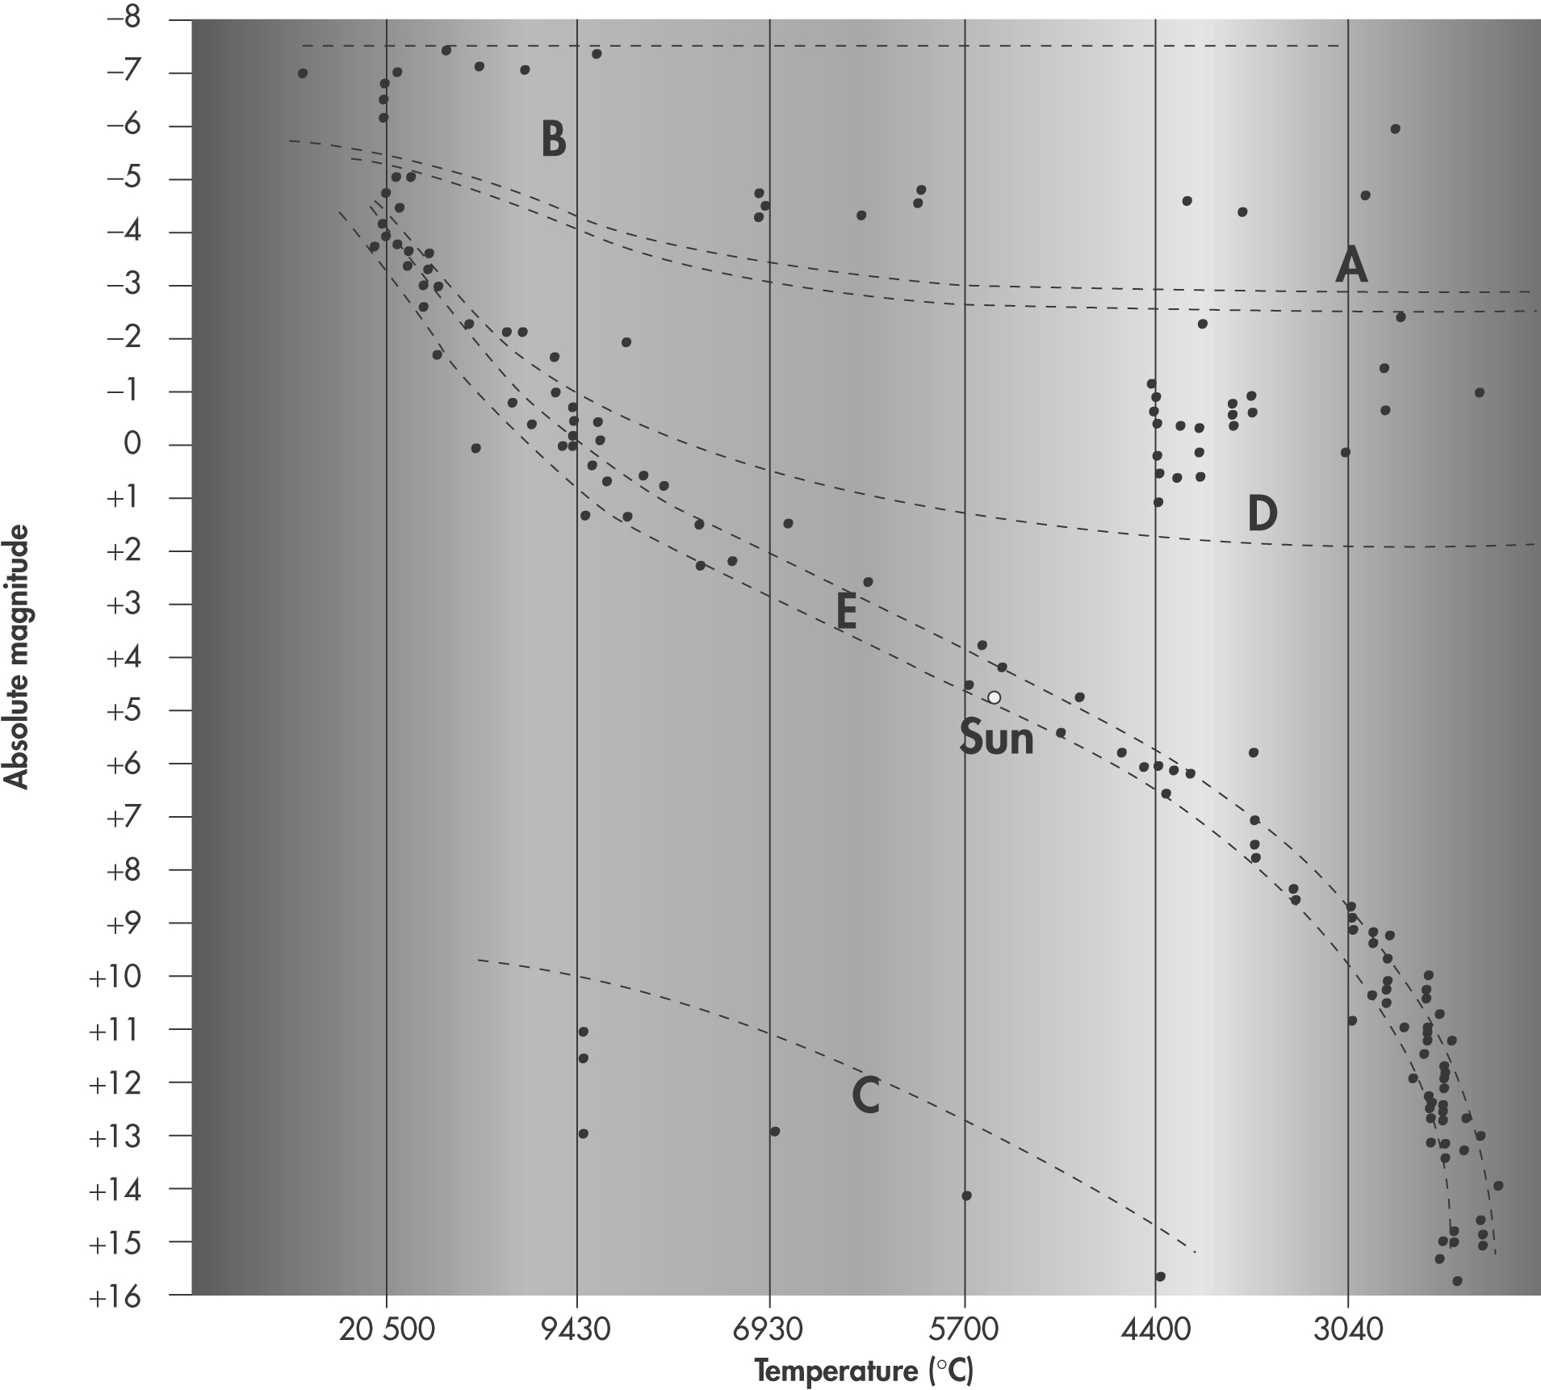

1. Where are the brightest stars located in this graph?
Along the top of the diagram

2. Where are the dimmest, coolest stars located in the graph?
At the bottom right of the diagram

3. Identify the type of star represented by the letters:
Red super giant
Blue super giant
White dwarf
Red giant
Main sequence stars
A:
B:
C:
D:
E:
4. During the next stage in our sun’s life cycle it will move off the main sequence of the graph. Which region of the graph (A–E) will it move to next?
Towards D (red giant)

5. Explain how the absolute magnitude of a star is different to its apparent magnitude.
(See page 2)
6. A star has an absolute magnitude of –6 and a surface temperature of 2900 °C.
(a) Predict the colour of this star.
Red

(b) Identify the group that this star belongs to.
Red super giant

The apparent magnitude is a star’s brightness as seen from Earth. A star’s absolute magnitude is the brightness of the star if it was measured at a distance of only 1 AU (the distance from the Earth to the sun). Since absolute magnitude is measured at the same distance from each star, it is therefore a better measure of a star’s brightness.
5.

